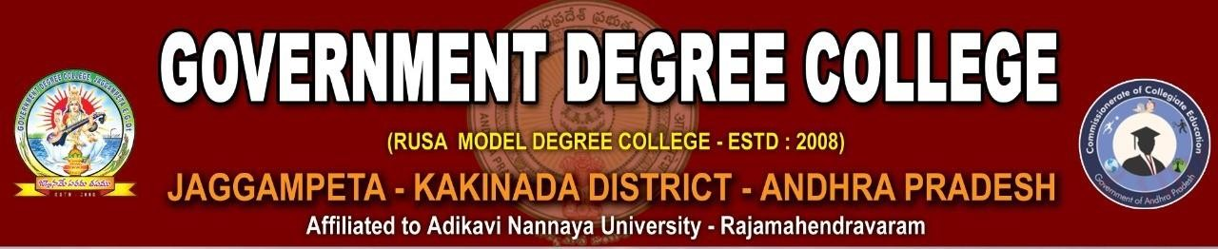

**Website**: [www.gdcjaggampeta.ac.in](http://www.gdcjaggampeta.ac.in/) **Mail ID**: [jkcrjyec.jaggampeta@gmail.com](mailto:jkcrjyec.jaggampeta@gmail.com)

**Cell:** 8328398875

# NEWSLETTER

**July - 2023**

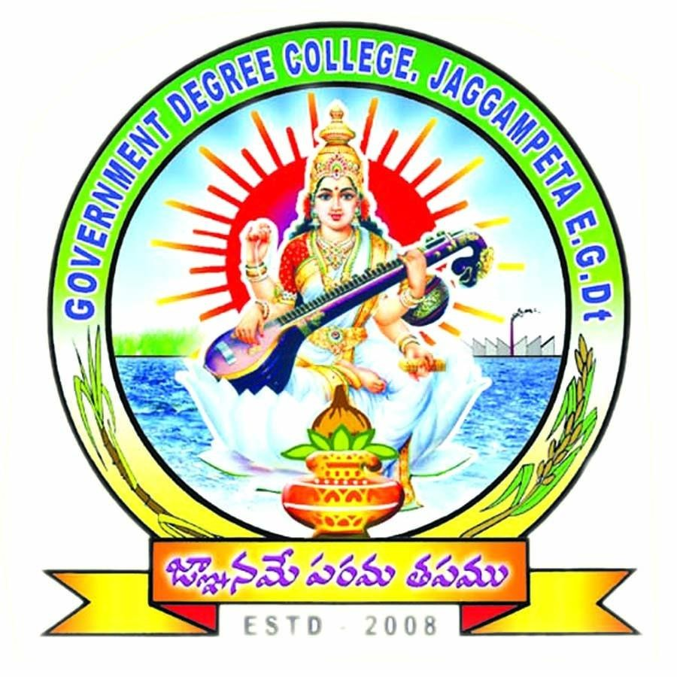

### Dr. E Chandra Naidu Ph.D

**Principal Government Degree College**

**Jaggampeta**

**World Environment Day**

#### 05 June, 2023

World Environment Day Celebration at Government Degree College, Jaggampeta

We are pleased to inform you that Government Degree College, Jaggampeta actively participated in the worldwide celebration of World Environment Day on June 5. This day holds significant importance as it raises awareness about environmental issues and encourages global action to protect our planet.

Under the theme "Ecosystem Restoration," the college organized a series of events and activities aimed at educating and engaging our college community in sustainable practices. The celebrations were a great success, with enthusiastic participation from both students and faculty members.

Here are some highlights from the World Environment Day celebrations at Government Degree College, Jaggampeta:

1. Tree Plantation Drive: A tree plantation drive was organized on the college campus. Students, faculty, and staff came together to plant a variety of saplings, contributing to the restoration and preservation of our local ecosystem.
2. Awareness Workshops: Informative workshops were conducted to enhance the knowledge of our college community regarding environmental issues. These sessions covered topics such as waste management, water conservation, and the importance of biodiversity.
3. Clean-up Drive: To promote cleanliness and waste management, a clean-up drive was organized in collaboration with local authorities. Students and faculty members actively participated in cleaning the nearby areas, fostering a sense of responsibility towards maintaining a clean and healthy environment.

Through these initiatives, Government Degree College, Jaggampeta demonstrated its commitment to environmental stewardship and sustainability. We believe that these small steps can collectively create a significant impact on our environment.

We extend our heartfelt gratitude to all the participants, volunteers, and faculty members who made the World Environment Day celebrations a grand success. Let us continue to work together, promoting a sustainable lifestyle and nurturing a healthier planet for generations to come.

Government Degree College, Jaggampeta

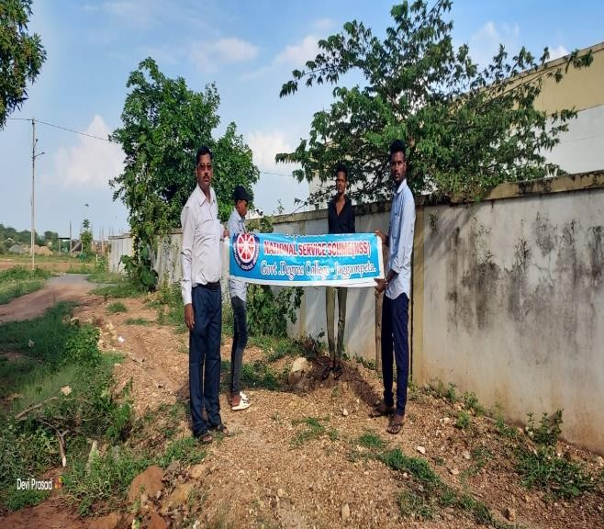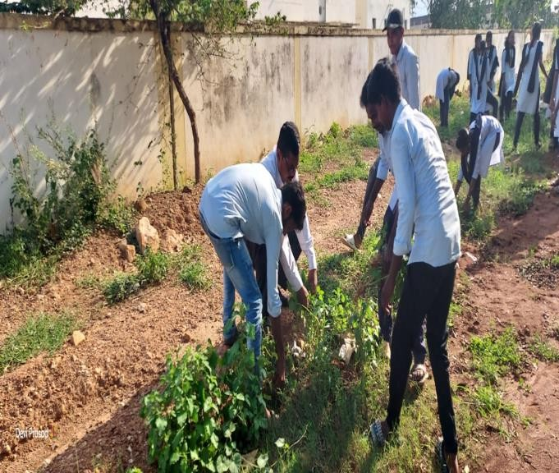

## World Day Against Child Labour

12 June 2023

World Day Against Child Labour - June 12

We are pleased to bring to your attention the significant event observed globally on June 12 - the World Day Against Child Labour. This day serves as a reminder to our society of the urgent need to eradicate child labour and protect the rights of children worldwide. Child labour remains a grave concern in many parts of the world, where millions of children are subjected to exploitative work conditions that deprive them of their childhood, education, and a bright future. It is our collective responsibility to raise awareness, advocate for change, and take concrete actions to eliminate child labour in all its forms.

The World Day Against Child Labour was first established in 2002 by the International Labour Organization (ILO), a specialized agency of the United Nations. Since then, it has been observed annually to promote dialogue and collaboration among governments, organizations, and individuals in the fight against child labour.

The theme for this year's World Day Against Child Labour is "Act Now: End Child Labour!" It calls for immediate and concerted action to eradicate child labour globally. The COVID-19 pandemic has exacerbated the vulnerability of children to exploitation, making it more crucial than ever to prioritize their protection and well-being.

As an educational institution, we have a pivotal role to play in creating awareness and fostering a sense of responsibility among our students and the wider community. We can contribute to the cause by engaging in discussions, organizing awareness campaigns, and encouraging responsible consumption and production practices that discourage the use of child labour.

Let us use this opportunity to reflect on the importance of education, the rights of children, and the moral obligation to create a world where every child can grow, learn, and thrive without being subjected to exploitative labor practices.

Together, let's pledge our commitment to the cause of ending child labour and work towards building a society where every child enjoys their fundamental rights and experiences the joys of childhood.

Wishing you all a meaningful World Day Against Child Labour.

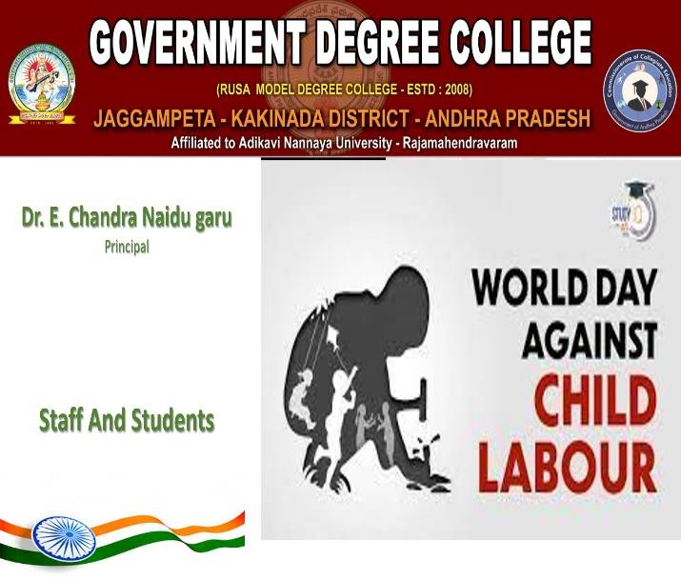 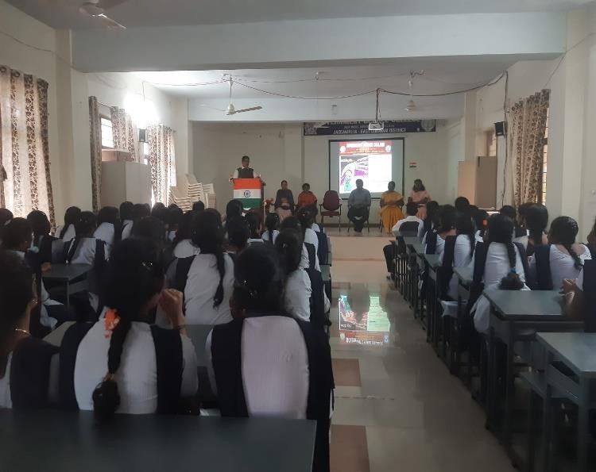

# World Blood Donor Day

#### 14 June, 2023

World Blood Donor Day - A Day to Save Lives

We hope this note finds you in good health and high spirits. We would like to take this opportunity to bring your attention to an important event that took place on 14th June - World Blood Donor Day.

Government Degree College, Jaggampeta, organized World Blood Donor Day an annually on June 14th to raise awareness about the importance of voluntary blood donation and to express gratitude to blood donors worldwide. This day serves as a reminder of the critical role that blood donors play in saving lives and improving health outcomes for patients in need.

The theme for this year's World Blood Donor Day was "Give blood and keep the world beating," emphasizing the vital contribution of blood donors in maintaining the health and well-being of communities. The campaign aimed to inspire people, particularly the youth, to donate blood regularly and ensure a safe and sustainable blood supply.

The significance of blood donation cannot be overstated. Blood transfusions are essential for various medical procedures, including surgeries, cancer treatments, trauma care, and the management of chronic illnesses. By donating blood, individuals can contribute to saving lives and improving the quality of life for patients in critical conditions.

The Department of Zoology, took an active part in commemorating World Blood Donor Day this year. We encourage all our students to continue promoting the importance of blood donation within the community. By spreading awareness and encouraging others to donate blood, we can save countless lives and make a substantial difference.

Once again, we extend our sincere thanks to everyone involved in making the World Blood Donor Day event a resounding success. Your dedication and support are commendable.

Wishing you all good health and happiness. With warm regards,

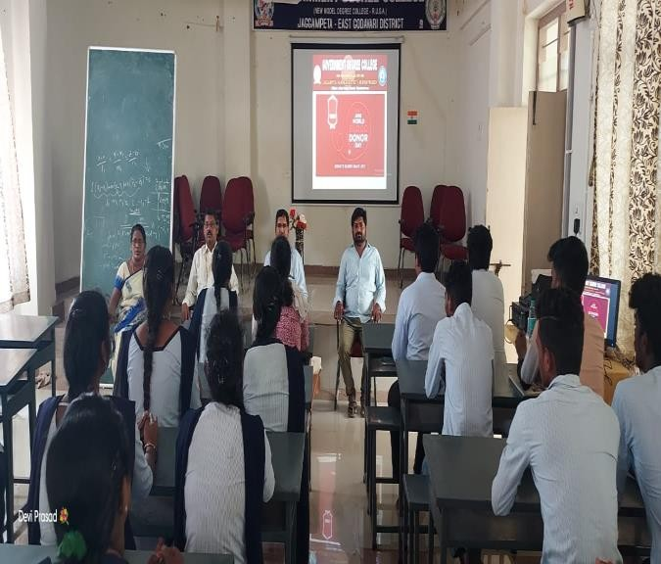 

# International Yoga Day

**21 June, 2023**

International Yoga Day Celebration at Government Degree College, Jaggampeta We are pleased to inform you that the Government Degree College in Jaggampeta

successfully celebrated International Yoga Day on 21 June. The event was organized by the college's Physical Education department, in collaboration with various student clubs and organizations.

International Yoga Day is observed worldwide to highlight the importance of physical and mental well-being through the practice of yoga. This year's theme focused on "Yoga for Wellness," emphasizing the holistic benefits that yoga brings to individuals and communities.

The day began with an inaugural ceremony, graced by the presence of esteemed dignitaries, including our Principal Dr. E. Chandra Naidu, faculty members, and invited guests from the local community. The event commenced with a collective prayer and the lighting of the ceremonial lamp, signifying the start of the celebration.

The college campus was beautifully decorated with colorful banners and informative displays, illustrating the significance of yoga in our daily lives. Various yoga asanas (postures) and pranayama (breathing exercises) were demonstrated by Sri Ramakrishna and Smt. Lakshmi yoga instructors. Students and faculty members actively participated in the sessions, practicing the asanas under expert guidance.

Additionally, special workshops were conducted to educate participants about the importance of yoga and its positive impact on physical and mental health. Renowned yoga experts were invited to share their knowledge and experiences, enlightening the audience about the scientific basis and benefits of yoga practices.

Moreover, an interactive session was held to address queries and concerns related to yoga. Participants were encouraged to ask questions, seek guidance, and clarify misconceptions regarding different aspects of yoga. This interactive platform provided a valuable opportunity for everyone to enhance their understanding of this ancient discipline.

The celebration also featured cultural performances that showcased the rich heritage of yoga and its influence on various art forms. Students presented mesmerizing yoga-inspired dance routines, promoting the fusion of tradition and creativity.

We extend our heartfelt gratitude to all the participants, instructors, volunteers, and organizing committee members who contributed to the grand success of this event. The dedication and enthusiasm displayed by the college community truly made this International Yoga Day celebration memorable.

Let us continue to embrace the practice of yoga in our daily lives and strive for physical and mental well-being. By incorporating yoga into our routines, we can cultivate a healthy and balanced lifestyle, enhancing our overall quality of life.

Once again, we congratulate everyone who actively participated in the International Yoga Day celebration. Together, let us continue to promote wellness and harmony through the ancient art of yoga.

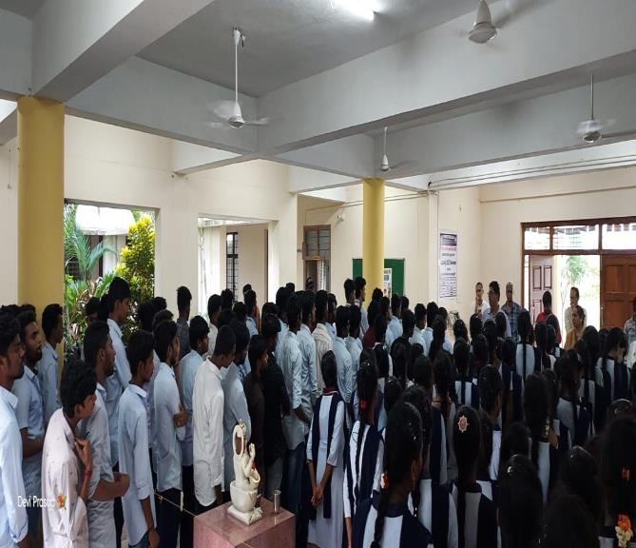 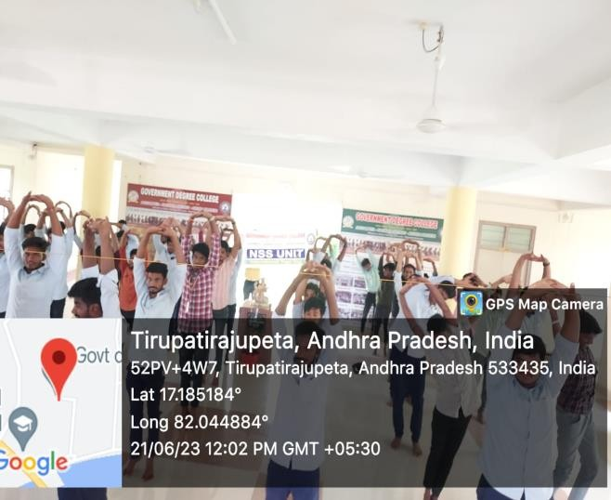

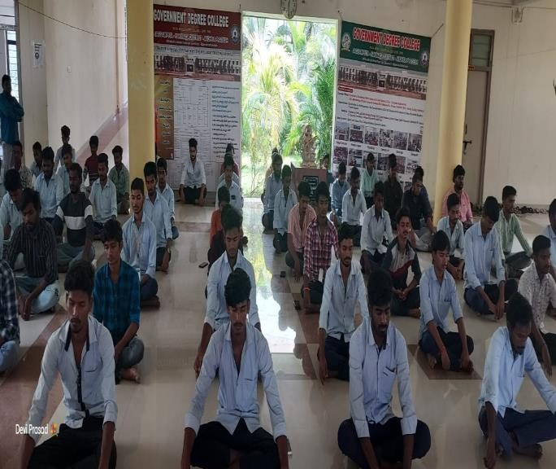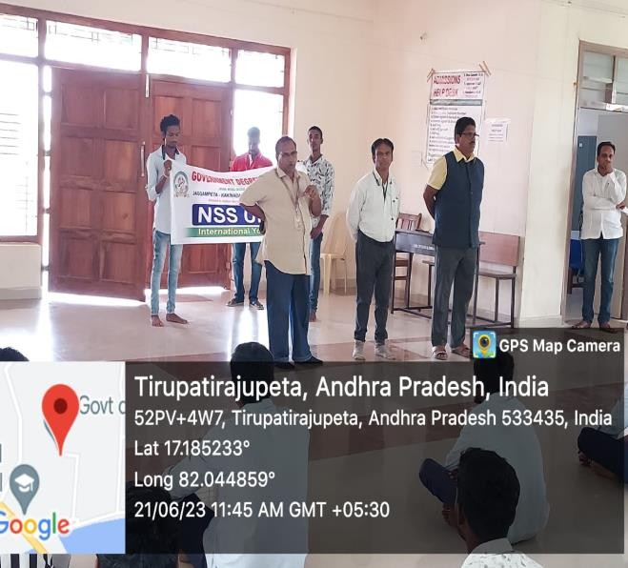

### International Day against Drug Abuse and Illicit Trafficking

**26th June 2023**

International Day against Drug Abuse and Illicit Trafficking - A Remarkable Event at Government Degree College, Jaggampeta

We are delighted to inform you that Government Degree College, Jaggampeta, commemorated the International Day against Drug Abuse and Illicit Trafficking with great enthusiasm and purpose on the 26th of June. This special event aimed to raise awareness about the grave consequences of drug abuse and the importance of combating illicit trafficking in our society.

The program witnessed the honorable presence of esteemed guests, Sri B. Surya Apparao, Circle Inspector of Jaggampeta, and Sri Vidya Sagar, Sub-Inspector of Jaggampeta. Their participation added great value and significance to the event.

The occasion began with an opening address by the Principal of Government Degree College, who highlighted the alarming rise of drug abuse and illicit trafficking and emphasized the need for collective efforts to address this issue effectively. The speakers emphasized the detrimental effects of drugs on individuals, families, and communities, emphasizing the importance of prevention, treatment, and rehabilitation.

Sri B. Surya Apparao, Circle Inspector of Jaggampeta, delivered an enlightening keynote speech on the legal aspects and the role of law enforcement agencies in combating drug abuse and illicit trafficking. His valuable insights shed light on the challenges faced by law enforcement officials and the measures being taken to curb the drug menace in our region.

Sri Vidya Sagar, Sub-Inspector of Jaggampeta, also addressed the audience, sharing practical knowledge and strategies to prevent drug abuse and illicit trafficking. His informative talk highlighted the significance of community engagement and collaborative efforts in creating a drug-free society.

The event included various activities aimed at engaging the attendees and promoting awareness. Students presented thought-provoking skits, recited impactful poems, and shared success stories of individuals who had overcome drug addiction. Interactive sessions and panel discussions allowed for an exchange of ideas, experiences, and concerns regarding drug abuse.

Government Degree College, Jaggampeta, expresses its heartfelt gratitude to Sri B. Surya Apparao and Sri Vidya Sagar for gracing the occasion as chief guests. Their presence and valuable contributions have left an indelible impact on all participants, inspiring them to join hands in the fight against drug abuse and illicit trafficking.

We extend our appreciation to all the faculty members, students, and attendees who actively participated and made this event a resounding success. Such initiatives play a vital role in raising awareness, fostering dialogue, and promoting a healthier and safer community.

Let us unite in our resolve to create a society free from the clutches of drug abuse and illicit trafficking. Together, we can make a difference!

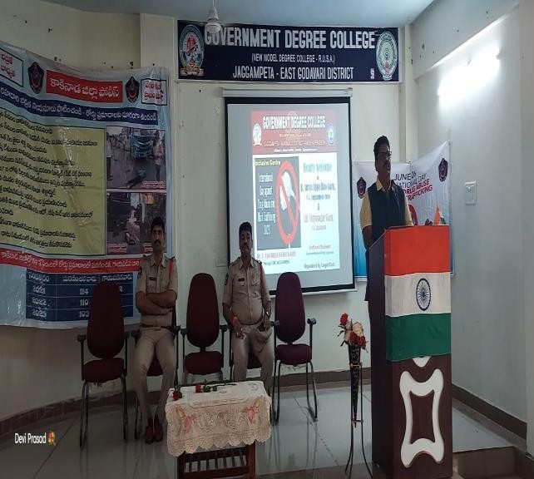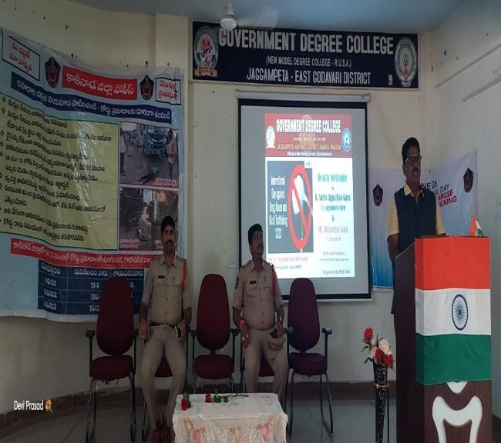

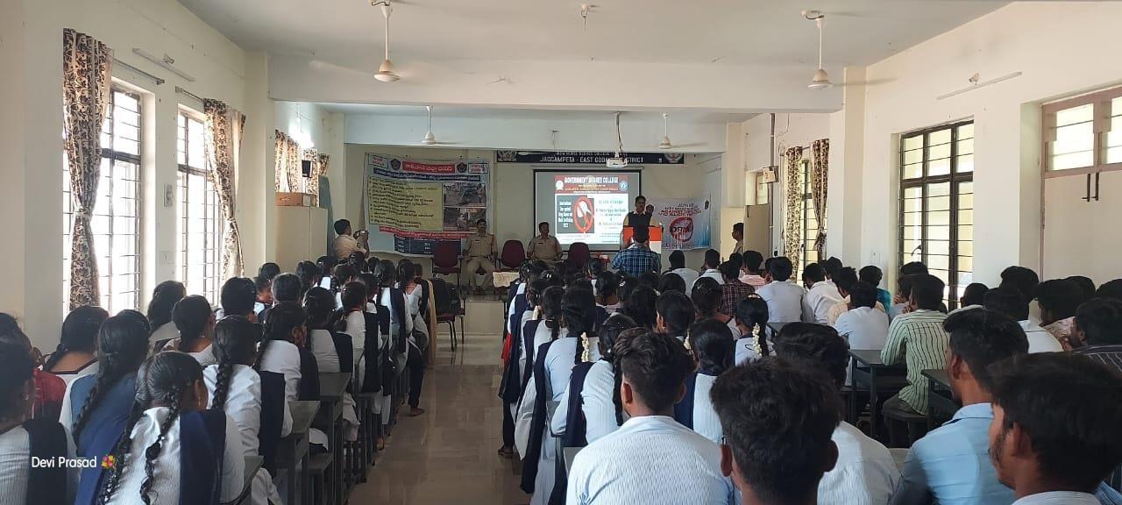

***The End***