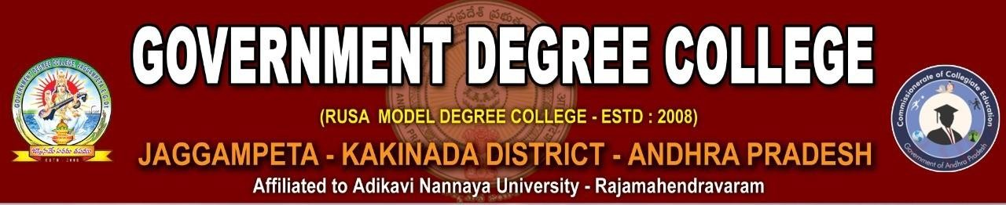

**Website**: [www.gdcjaggampeta.ac.in](http://www.gdcjaggampeta.ac.in/) **Mail ID**: [jkcrjyec.jaggampeta@gmail.com](mailto:jkcrjyec.jaggampeta@gmail.com)

**Cell:** 8328398875

# NEWSLETTER

## MAY - 2023

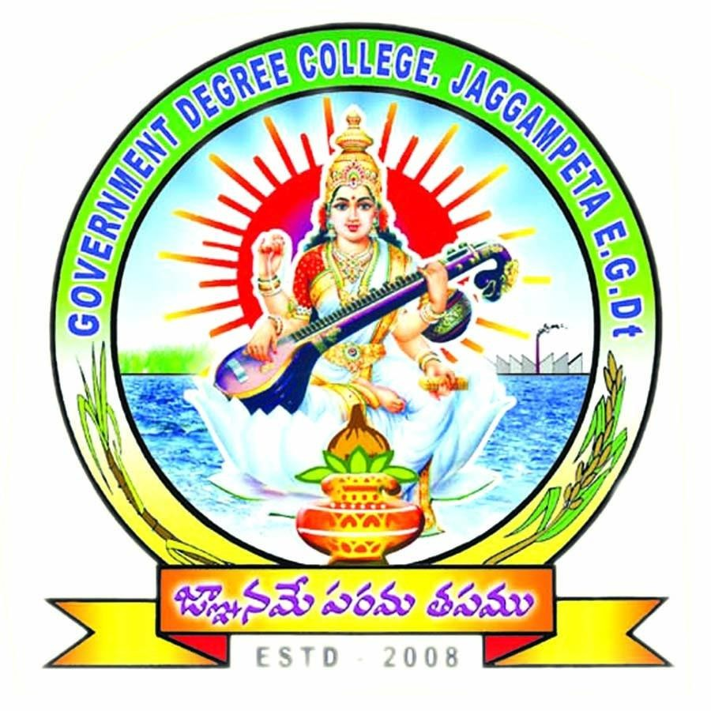

**Dr. E Chandra Naidu Ph.D**

#### Principal Government Degree College

**Jaggampeta**

# Babu Jagjivan Ram Jayanti

###### 05 April, 2023

April 5th is celebrated as the birth day of Babu Jagjivan Ram who fought for social justice and equality. He took active part in the drafting of the Indian constitution and worked for abolition of untouchability. Our principal Dr, E. Chandra Naidu offered floral tributes to the port raid of jagajivan ram and spoke on the contributions of jagjivan ram. All staff and students were present. He exhorted the youth to involve in social service to build healthy society.

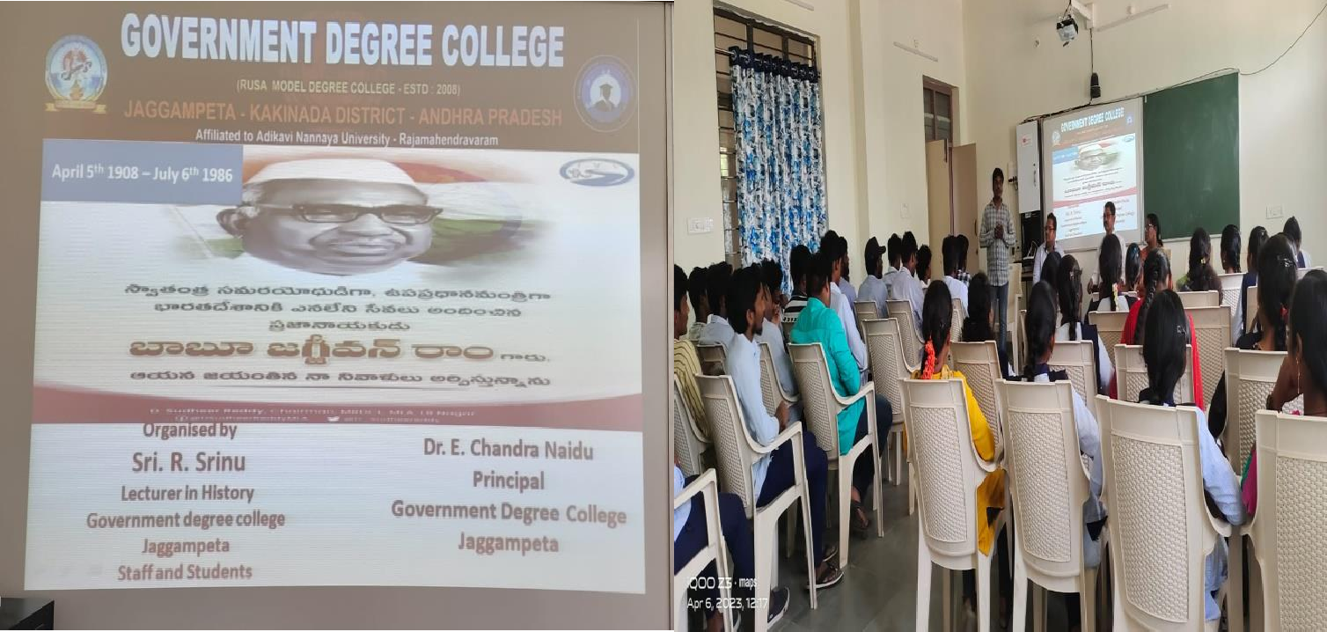

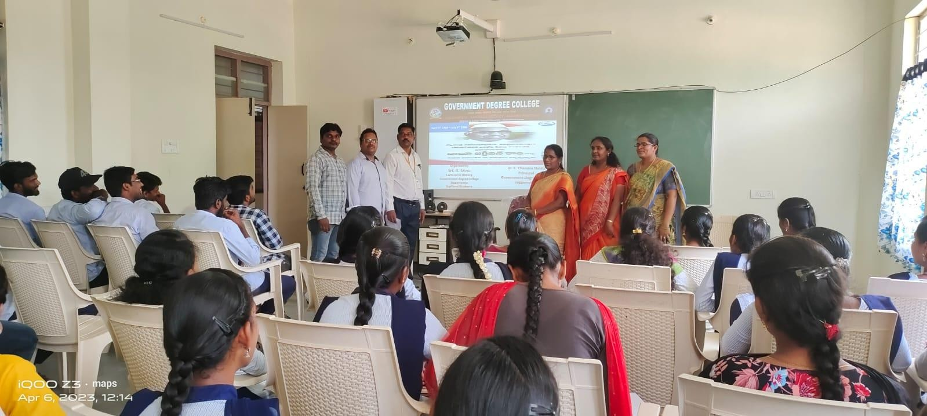

**World Health Day**

##### 7 April 2023

On the occasion of World Health Day, Zoology Department of Government Degree College, Jaggampet, organized a program. On this occasion, College Principal Dr. E. Chandra Naidu said that health diseases are one of the major problems facing the world at present, despite the availability of medical and medicines. New diseases are emerging and the main reason for this is the change in our lifestyle and food habits. Zoology lecturer Sri P. Srinivasa Rao said that neglecting the environment is always dangerous for humanity, so planting trees and forests and adopting traditional farming methods and changing food habits can prevent most of the diseases.

As part of this programme, posters created by the students were displayed on topics such as health problems and medical facilities.

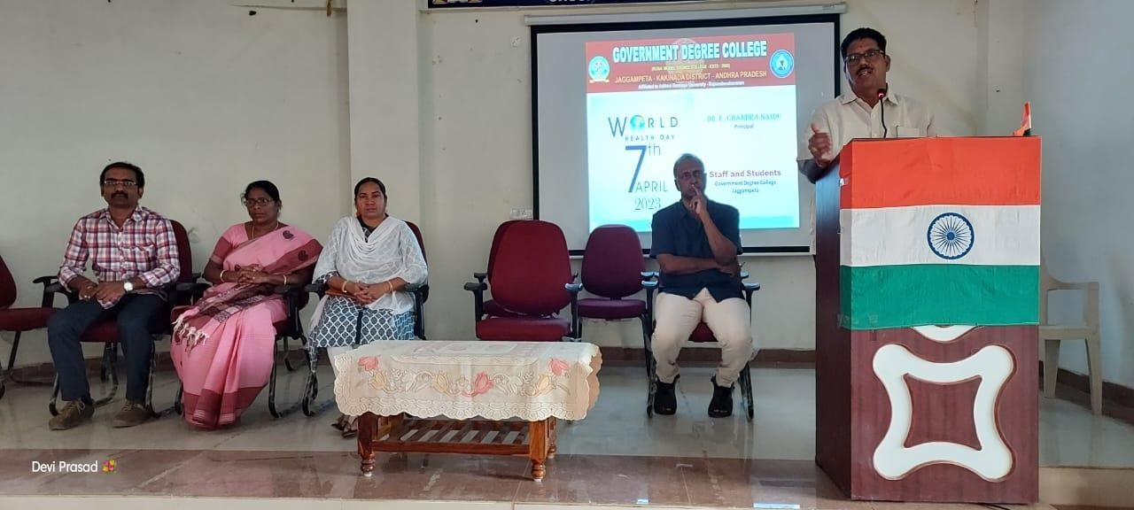

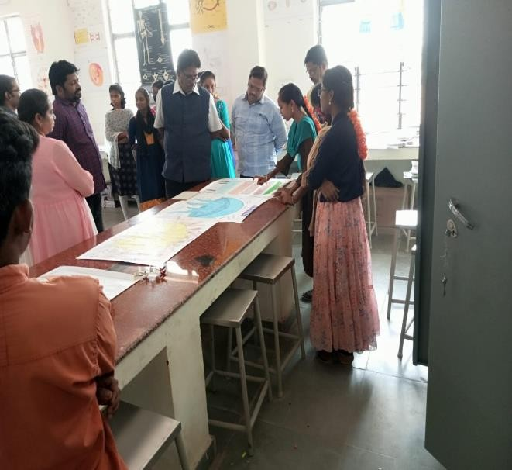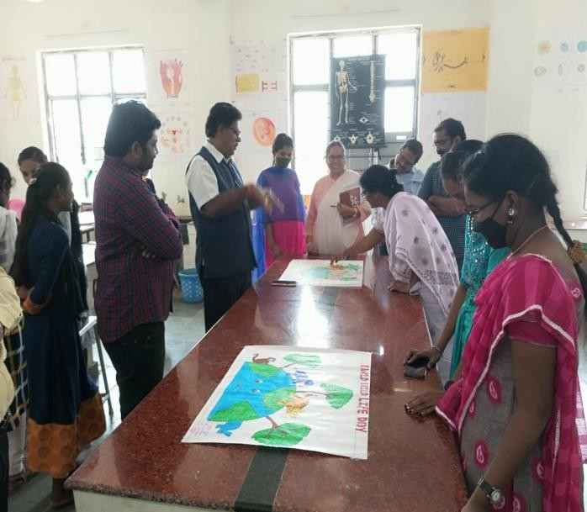

Jyotirao Phule birth Anniversary

**11 April, 2023**

Government Degree College Jaggampeta celebrated Birth Anniversary of Jyotirao Phule. On this occasion our principal Dr. E. Chandra Naidu remembered the services of Sri Jyotirao Phule who dedicated his entire life for the upliftment of Dalit, Backward Castes and women welfare development. Reiterating the ideas and goals of Jyotirao Phule, the society would pursue its actions ensuring to unveil the concept of equality of all sections in all sectors

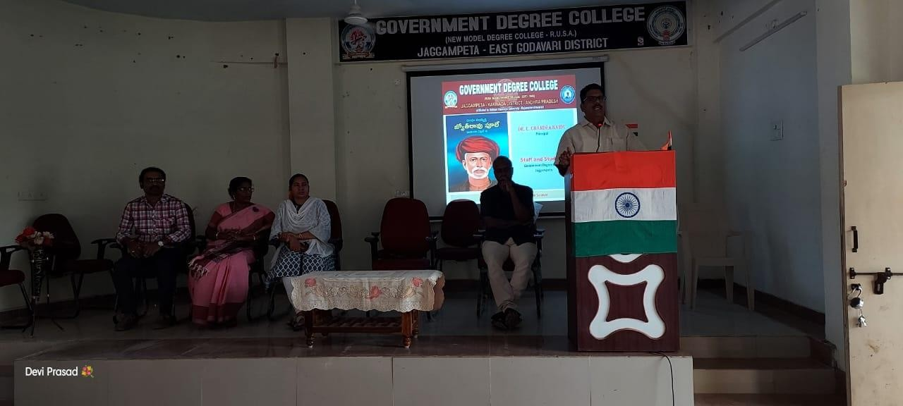

Government Degree College Jaggampeta Conducts Orientation Programme on OJT/ Six Months Internship.

**11 and 12 April, 2023**

The Commissioner of Collegiate Education took initiative to provide hands on exposure and professional competence to degree under graduation. It is designed to enhance their skills and knowledge and enable them to handle latest technologies in various sectors.

Dr. E. Chandra Naidu Principal Of this college accommodated all final year students in various industries, like LG Services, Charted Accountant, farm, cashew industry, Rice mill, Electrical tools manufacturers, hospital and fruit Industries. College

Internship Coordinator V V V Siva Prasad conducted a two-day workshop on importance of Internship and how to develop social responsibilities, communication skills, discipline in work place, managerial Skills, Marketing Skills and Leadership qualities during the Internship period. He expressed his thanks to Dr. E. Chandra Naidu for successful completion of workshop

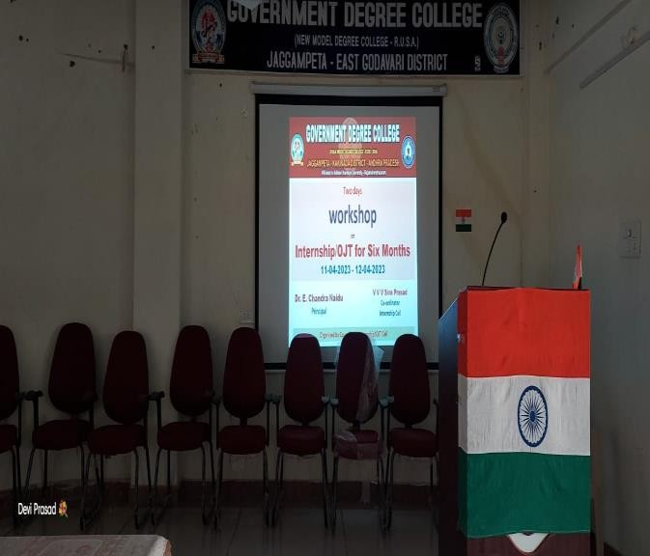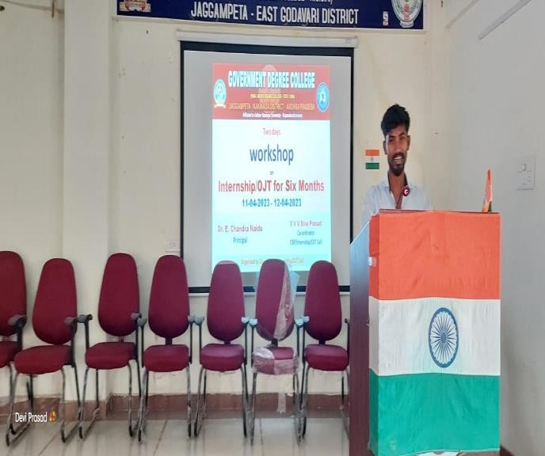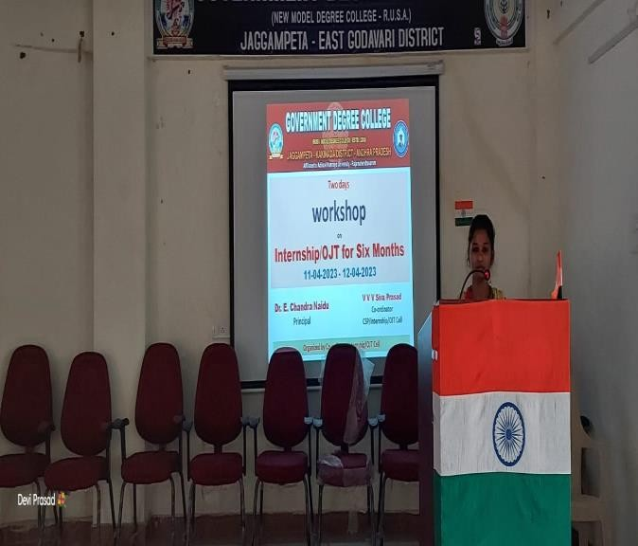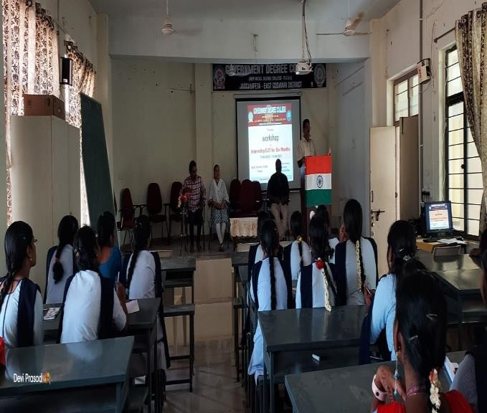

Jallianwala Bagh Massacre

**13 April 2023**

Government degree college Commemorates the Jallianwala Bagh Massacre. All students and staff saluted the martyrs of Jallianwala Bagh massacre. The department of History conducted a meeting, how general dyer had killed the protesters who protested against Rowlatt act mercilessly. Protestors could not escape as the exists were blocked. All people disgusted by the actions of British, Rabindranath Tagore gave up his knighthood.

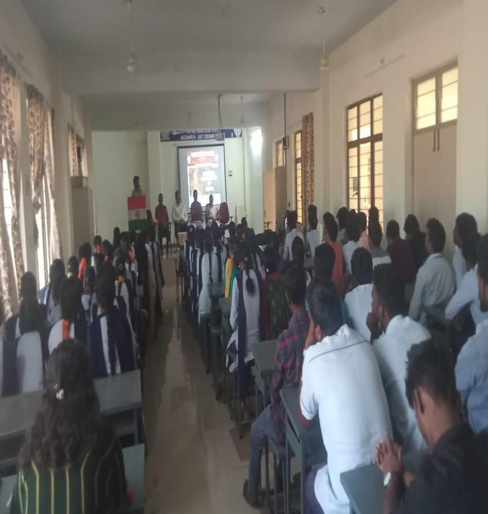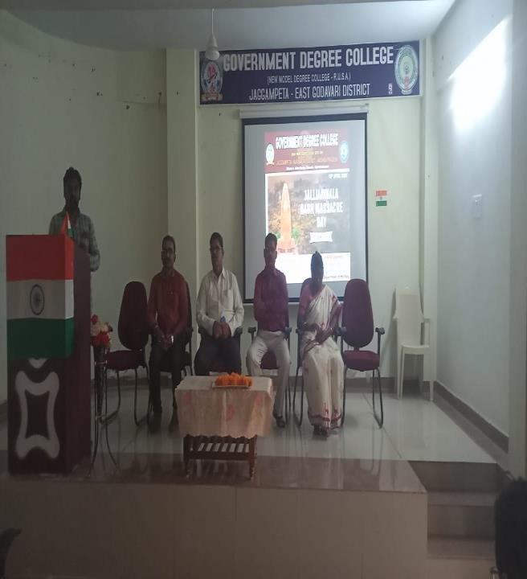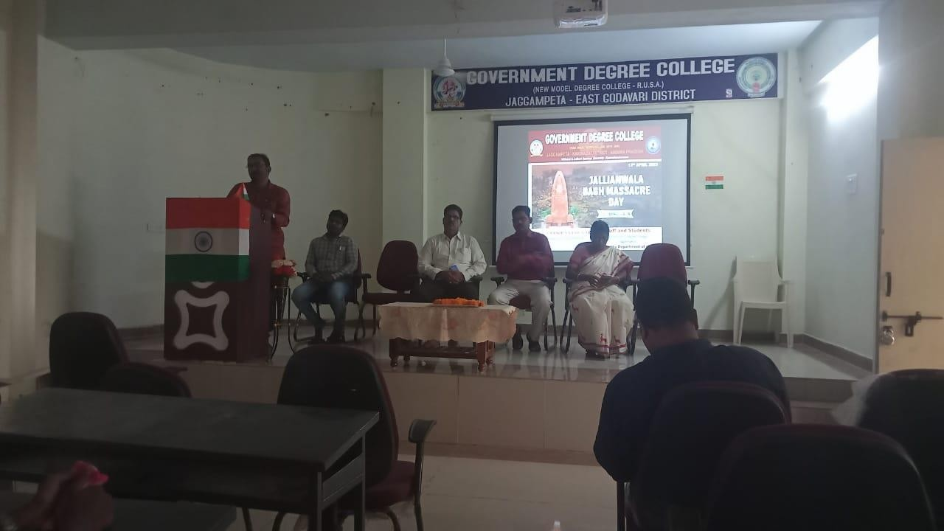

**Dr. B. R. Ambedkar Jayanti**

###### 14 April, 2023.

GDC Jaggampeta commemorates the 132nd Birth anniversary of Dr. B.R. Ambedkar. Dr. B.R. Ambedkar Jayanti holds a significate role in every one’s life. The whole college honored the Dr. B.R. Ambedkar and paid respects to Ambedkar portrait. Dr. E. Chandra Naidu Said that he is the father of the Indian constitution. He handled many social movements for equality. And he said that his vision on for India’s future went much beyond. His relevance is magnified as the world came across with incidents of violation of human rights and Political freedom. He urged the students to do research on Ambedkar’s vision The head of the Department of Political Science V.V.V. Siva Prasad emphasized that equality, liberty and fraternity can be obtained by way of social democracy.

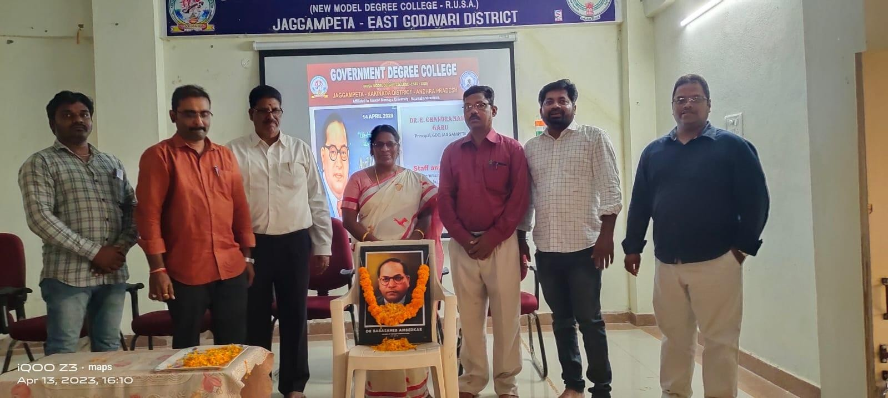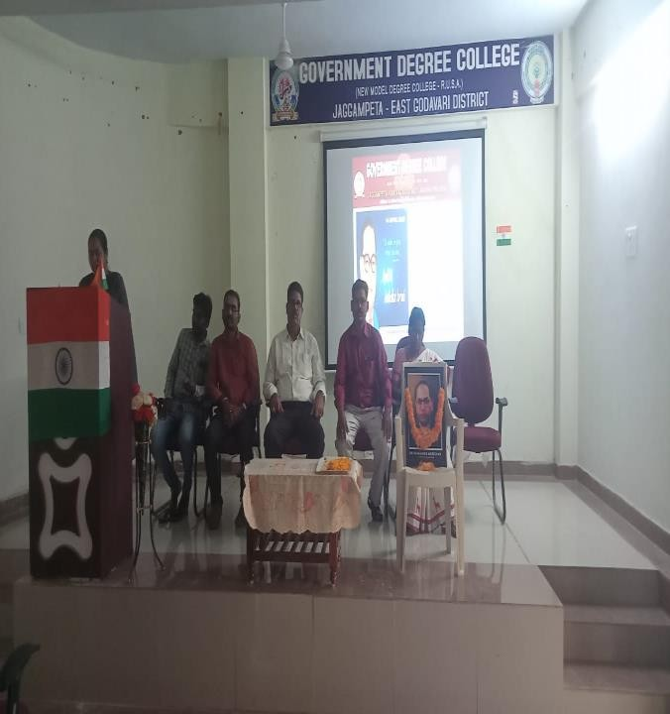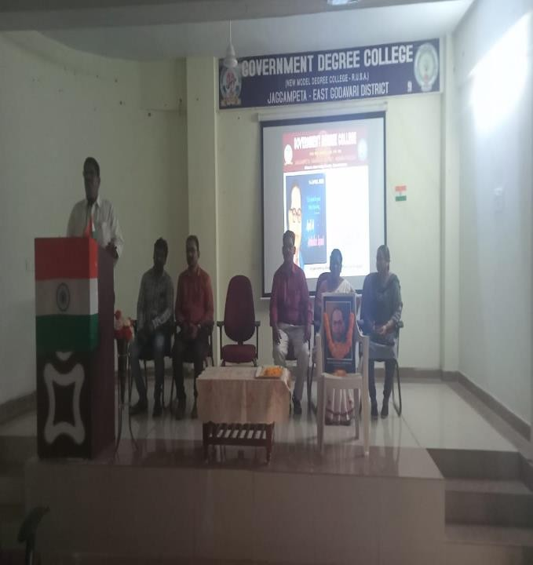

### English Language Day

#### (Birth Anniversary of Shakespeare)

###### 23 April, 2023

April 23rd day is observed as English Language Day and Birth Anniversary of Shakespeare. Its aim is to celebrate multilingualism and cultural diversity by exploring the language. Shakespeare is also called as the BARD OF AVON. He wrote on 39 plays, 154 sonnets and many other unclassified works. Shakespeare is the hero of the world with themes that still resonate with readers and theatergoers. His dramatic mechanics give virtual reality experience and enthrall the spectators. It can proudly say Shakespeare legacy various characters, lines and emptions of romans which are immortal. The principal Dr. E. Chandra Naidu and Staff garlanded the portrait of Shakespeare. He said that he is the world’s greatest dramatist. He concluded that beauty and grandeur of Shakespeare has been continuing till today.

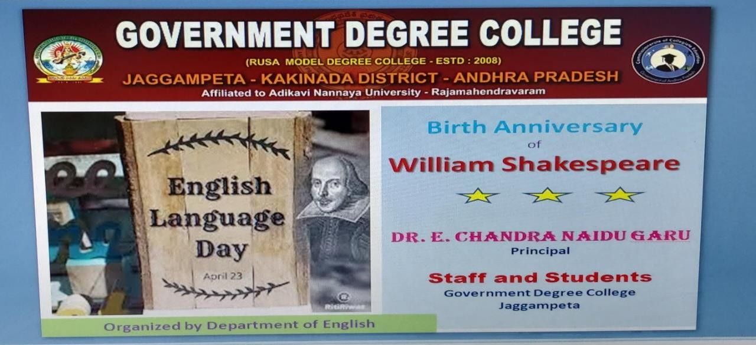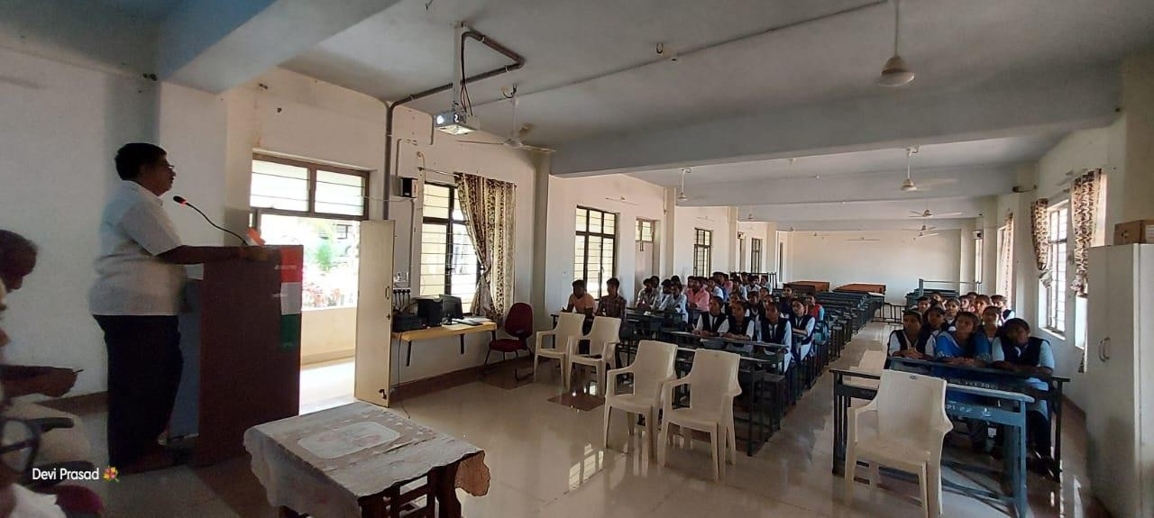

World Book Day

###### 23 April, 2023

World book day is celebrated and focuses on love for reading, writing and acquiring knowledge. It creates awareness of education and books which make the reader to think. Books are essential for every person from all walks of life. World book day focuses and promotes the diversity of native language of a country and promotes the protection of copy rights, authors and publishers.

Its holds significant that knowledge and wisdom unite the people. It forms a link between the past and the present to connect the generations and cultures of past. The principal said that books are invaluable possessions which enhance our intellect. He appealed the students to inculcate the reading habit and creates a sense of competitions in one’s life.

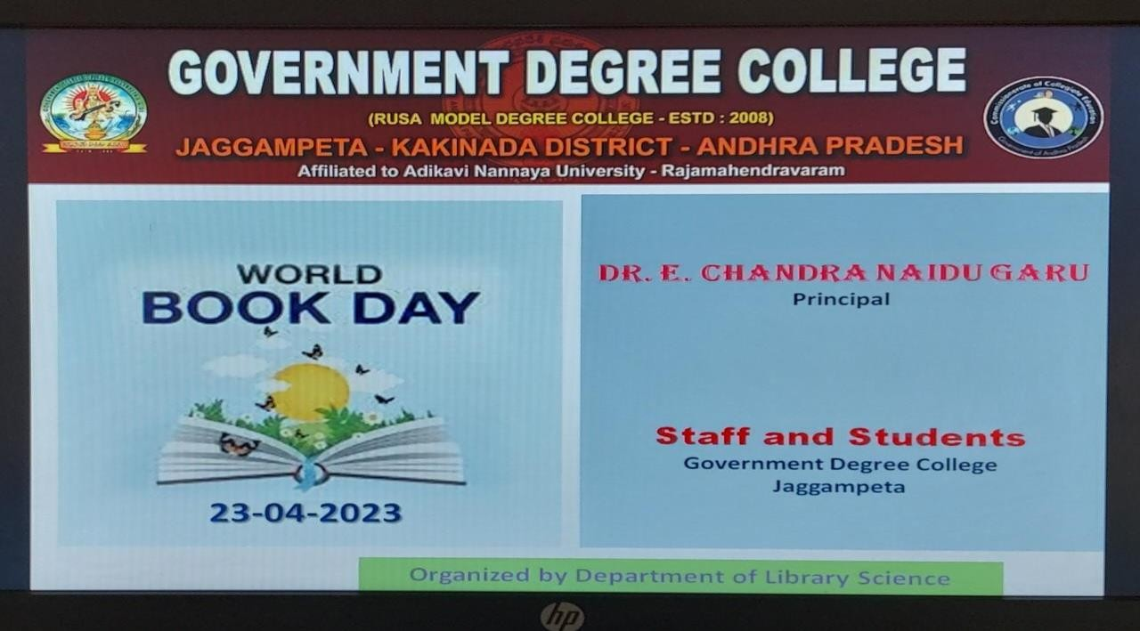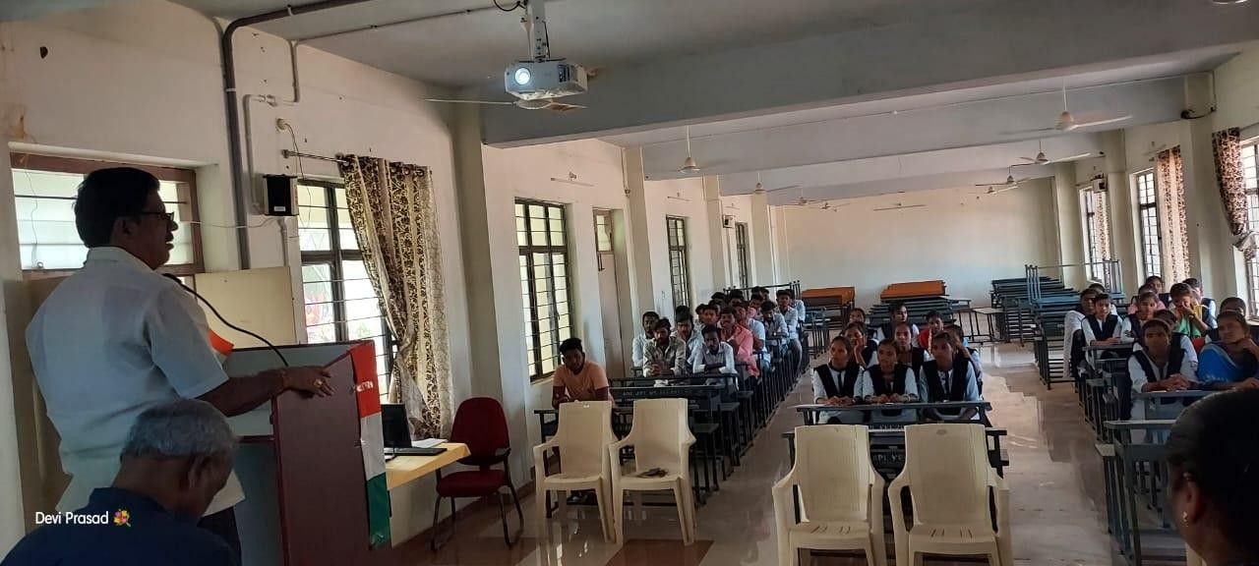

***The End***